**INTI International College Penang School of Computing**

**3+0 Bachelor of Science (Hons) in Computer Science, in collaboration with Coventry University, UK 3+0 Bachelor of Science (Hons) in Computing, in collaboration with Coventry University, UK**

# Coursework cover sheet

**Section A - To be completed by the student.**

|  |  |
| --- | --- |
| Full Name: Lim Sheue Ying | |
| CU Student ID Number: P22014796 | |
| Semester: 2 | |
| Session:  **April 2023** | |
| Lecturer:  **Puteri Nursyawati Azzuri (puteri.azzuri@newinti.edu.my)** | |
| Module Code and Title:  **4067CEM Software Design** | |
| Assignment No. / Title:  **Continuous Assessment** | % of Module Mark:  **50** |
| Hand out Date:  **12 May 2023** | Due Date:  **Task 1: 02 June 2023, by 11.59pm.**  **Task 2: 07 July 2023, by 11.59pm**  **Task 3: 07 July 2023, by 11.59pm.**  **Task 4: 07 July 2023, by 11.59pm.**  **Task 5: 07 July 2023, by 11.59pm.** |
| Penalties: No late work will be accepted. If you are unable to submit coursework on time due  to extenuating circumstances, you may be eligible for an extension. Please consult the lecturer. | |
| Declaration: I/we the undersigned confirm that I/we have read and agree to abide by the University regulations on plagiarism and cheating and Faculty coursework policies and procedures. I/we confirm that this piece of work is my/our own. I/we consent to the appropriate storage of our work for plagiarism checking.  Signature(s): | |

# Section B - To be completed by the module leader

|  |  |  |
| --- | --- | --- |
| Intended learning outcomes assessed by this work:   1. Understand and apply appropriate concepts, tools, and techniques to each stage of the software development. 2. Understand and apply design patterns to software components in developing new software. 3. Demonstrate an understanding of project planning and working to agreed deadlines, along with professional, interpersonal skills and effective communication required for software production.   5. Demonstrate an awareness of, and ability to apply, social, professional, legal, and ethical standards as documented in relevant laws and professional codes of conduct such as that of  the Malaysian National Computer Confederation. | | |
| Marking scheme | Max | Mark |
| 1. User Story Mapping | 20 |  |
| 2. Setting up a GitHub |  |
| Repository | 10 |
| 3. Creating a Class diagram and |  |
| design pattern selection | 30 |
| 4. Creating a Prototype User |  |
| Interface and Usability Testing | 20 |
| 5. Discuss the ethical issue |  |
| related to the software | 20 |
| Total | 100 |  |

Task 4 – Creating a Prototype User Interface and Usability Testing (20 marks)

Create a Prototype User Interface (hand drawn/digital) of TWO (2) important functions of the proposed system. Come up with usability testing questions. You don’t have to carry out the test, just prepare the questions. You should indicate what you are testing for in the Usability Testing.

Output – A Prototype and Usability Testing Questions. In Word format, uploaded it to GitHub.

**List of Content**

1.0 Prototype User Interface ……………………………………………………………………….5

1.1 Project Management User Interface …………………………………………………5

1.2 Inventory User Interface ………………………………………………………………11

2.0 Usability Testing………………………………………………………………………………...19

2.1 Usability Testing Questions …………………………………………………………..19

**List of Figure**

Figure 1.1 Login Page ………………………………………………………………………………5

Figure 1.2 Registration Page ………………………………………………………………………6

Figure 1.3 Home Page ……………………………………………………………………………..7

Figure 1.4 Project Management Page ……………………………………………………………8

Figure 1.5 Track Progress ………………………………………………………………………….9

Figure 1.6 Team Chat ……………………………………………………………………………...10

Figure 1.7 Team Call ……………………………………………………………………………….11

Figure 1.8 Inventory Page …………………………………………………………………………12

Figure 1.9 Add Product …………………………………………………………………………….13

Figure 1.10 Report Page …………………………………………………………………………..14

Figure 1.11 Supplier List …………………………………………………………………………..15

Figure 1.12 Add Supplier …………………………………………………………………………..16

Figure 1.13 Order Page …………………………………………………………………………....17

Figure 1.14 Add New Order ……………………………………………………………………….18

1. **Prototype User Interface**

The prototype user interface for the Student Business System named StudentBiz, is a visual representation of the proposed system's interface design. The prototype user interface showcases two important functions of the proposed system: Project Management and Inventory. The user interface has been designed to provide a user-friendly and intuitive experience, allowing college students running businesses to effectively manage their projects and inventory.

**1.1 Project Management User Interface**

The Project Management function is aimed at helping users plan, organize, and track their business projects efficiently. It offers features such as creating project tasks, assigning responsibilities, setting deadlines, monitoring project progress, and communicating with team members. By utilizing this function, users can stay on top of their project timelines, collaborate with team members, and ensure successful project completion.

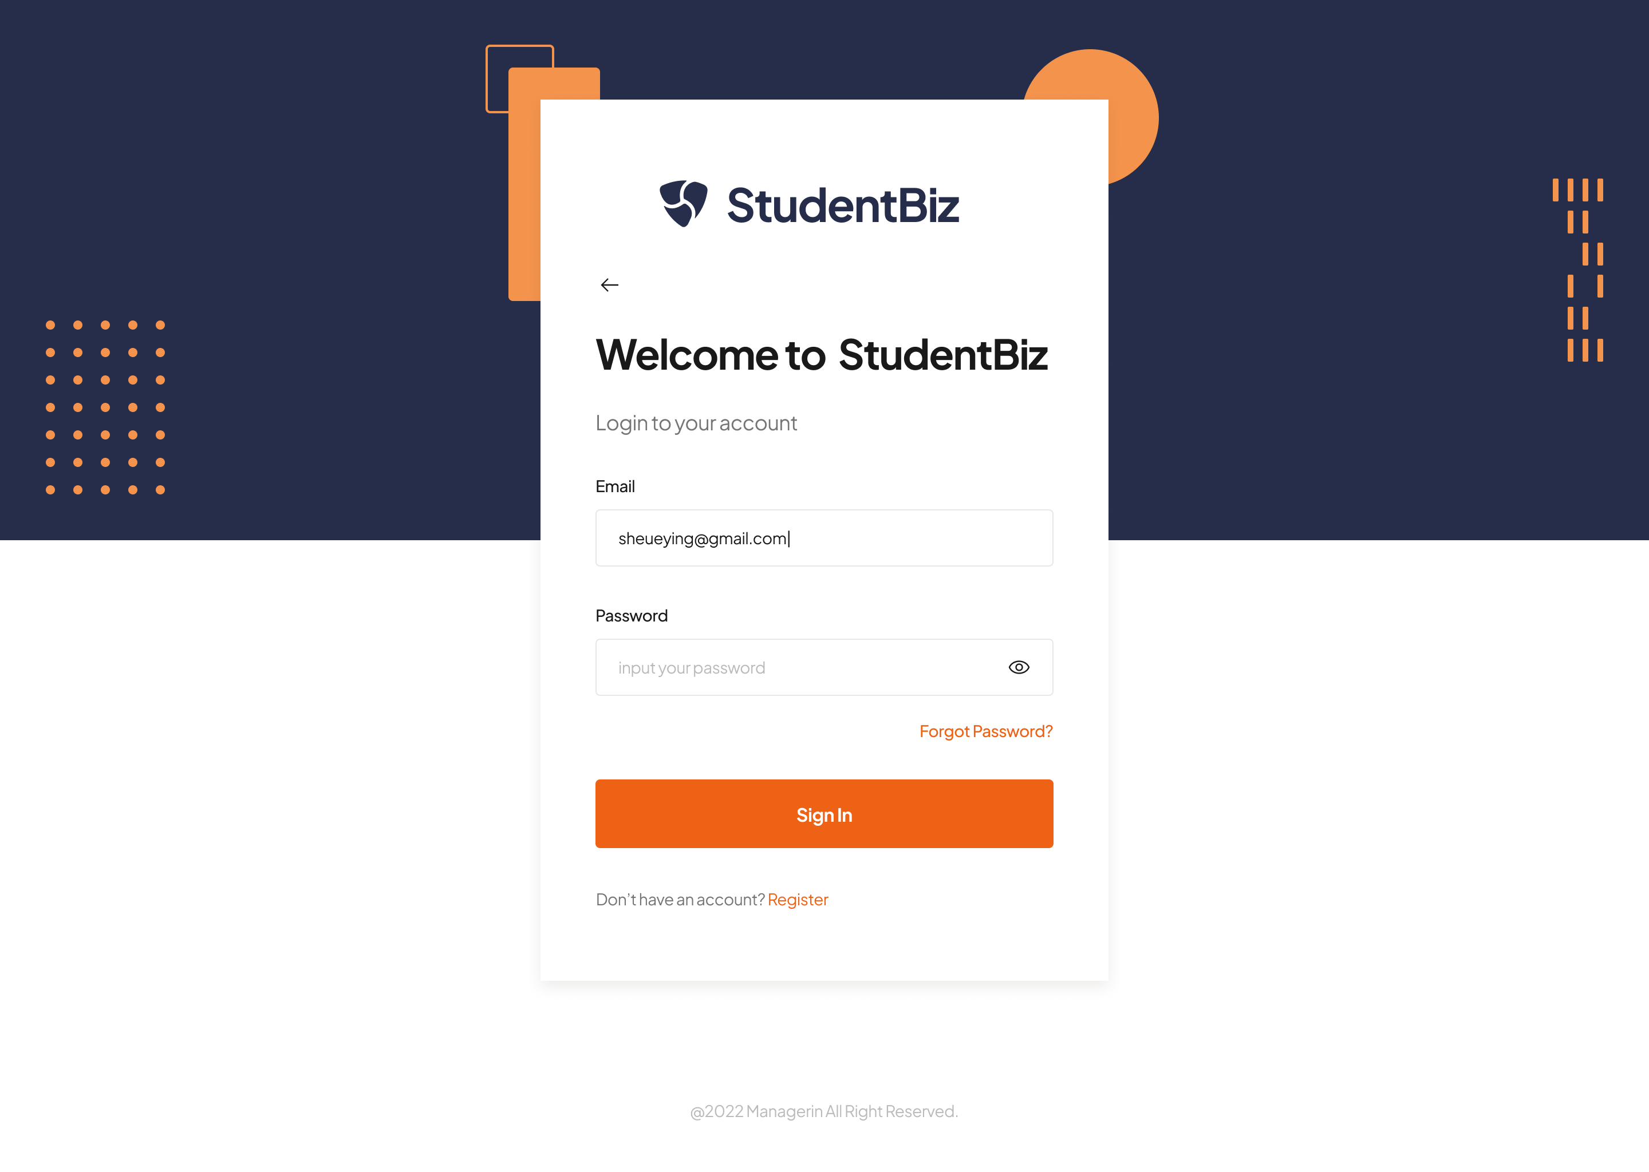

Figure 1.1 shows the login page of the StudentBiz system which allows users to fill in the email address and the password.

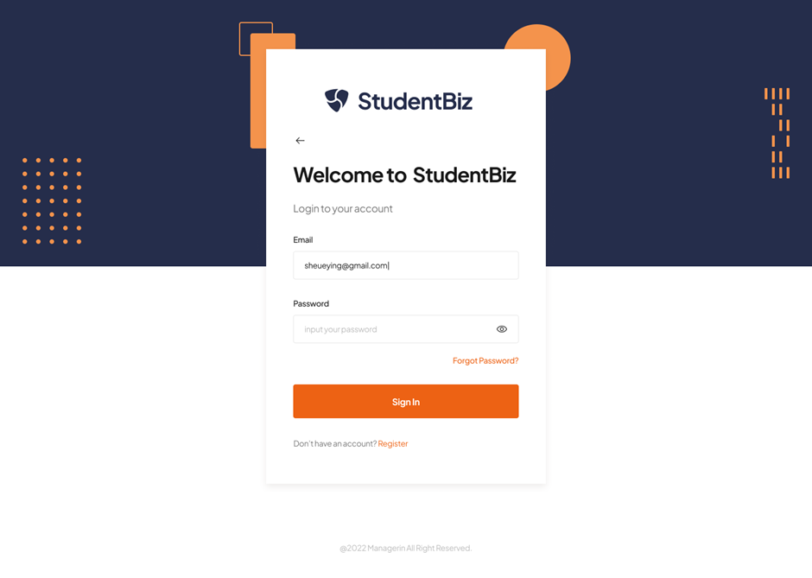

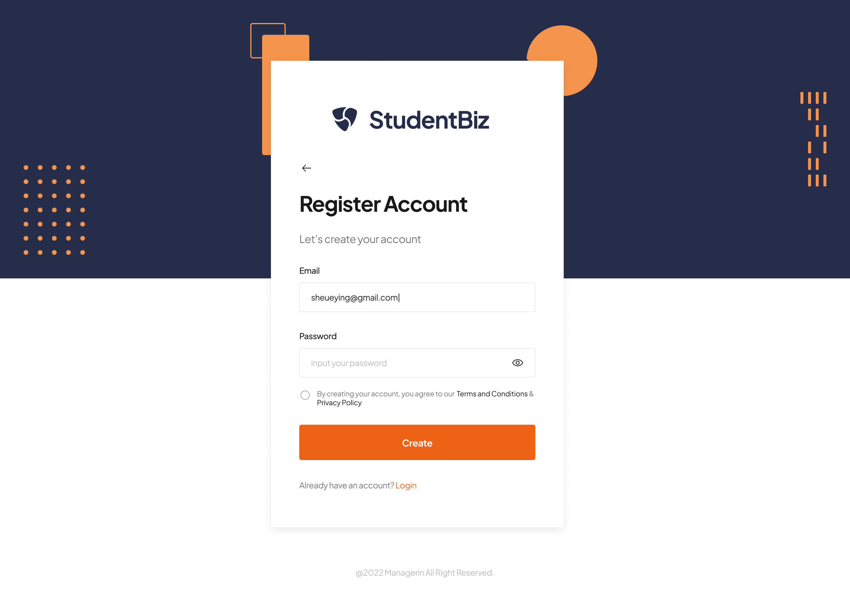

Figure 1.2 shows the registration page which allows new users to register an account by entering their email address and creating a password. A new account will be created after agreeing to the terms and conditions.

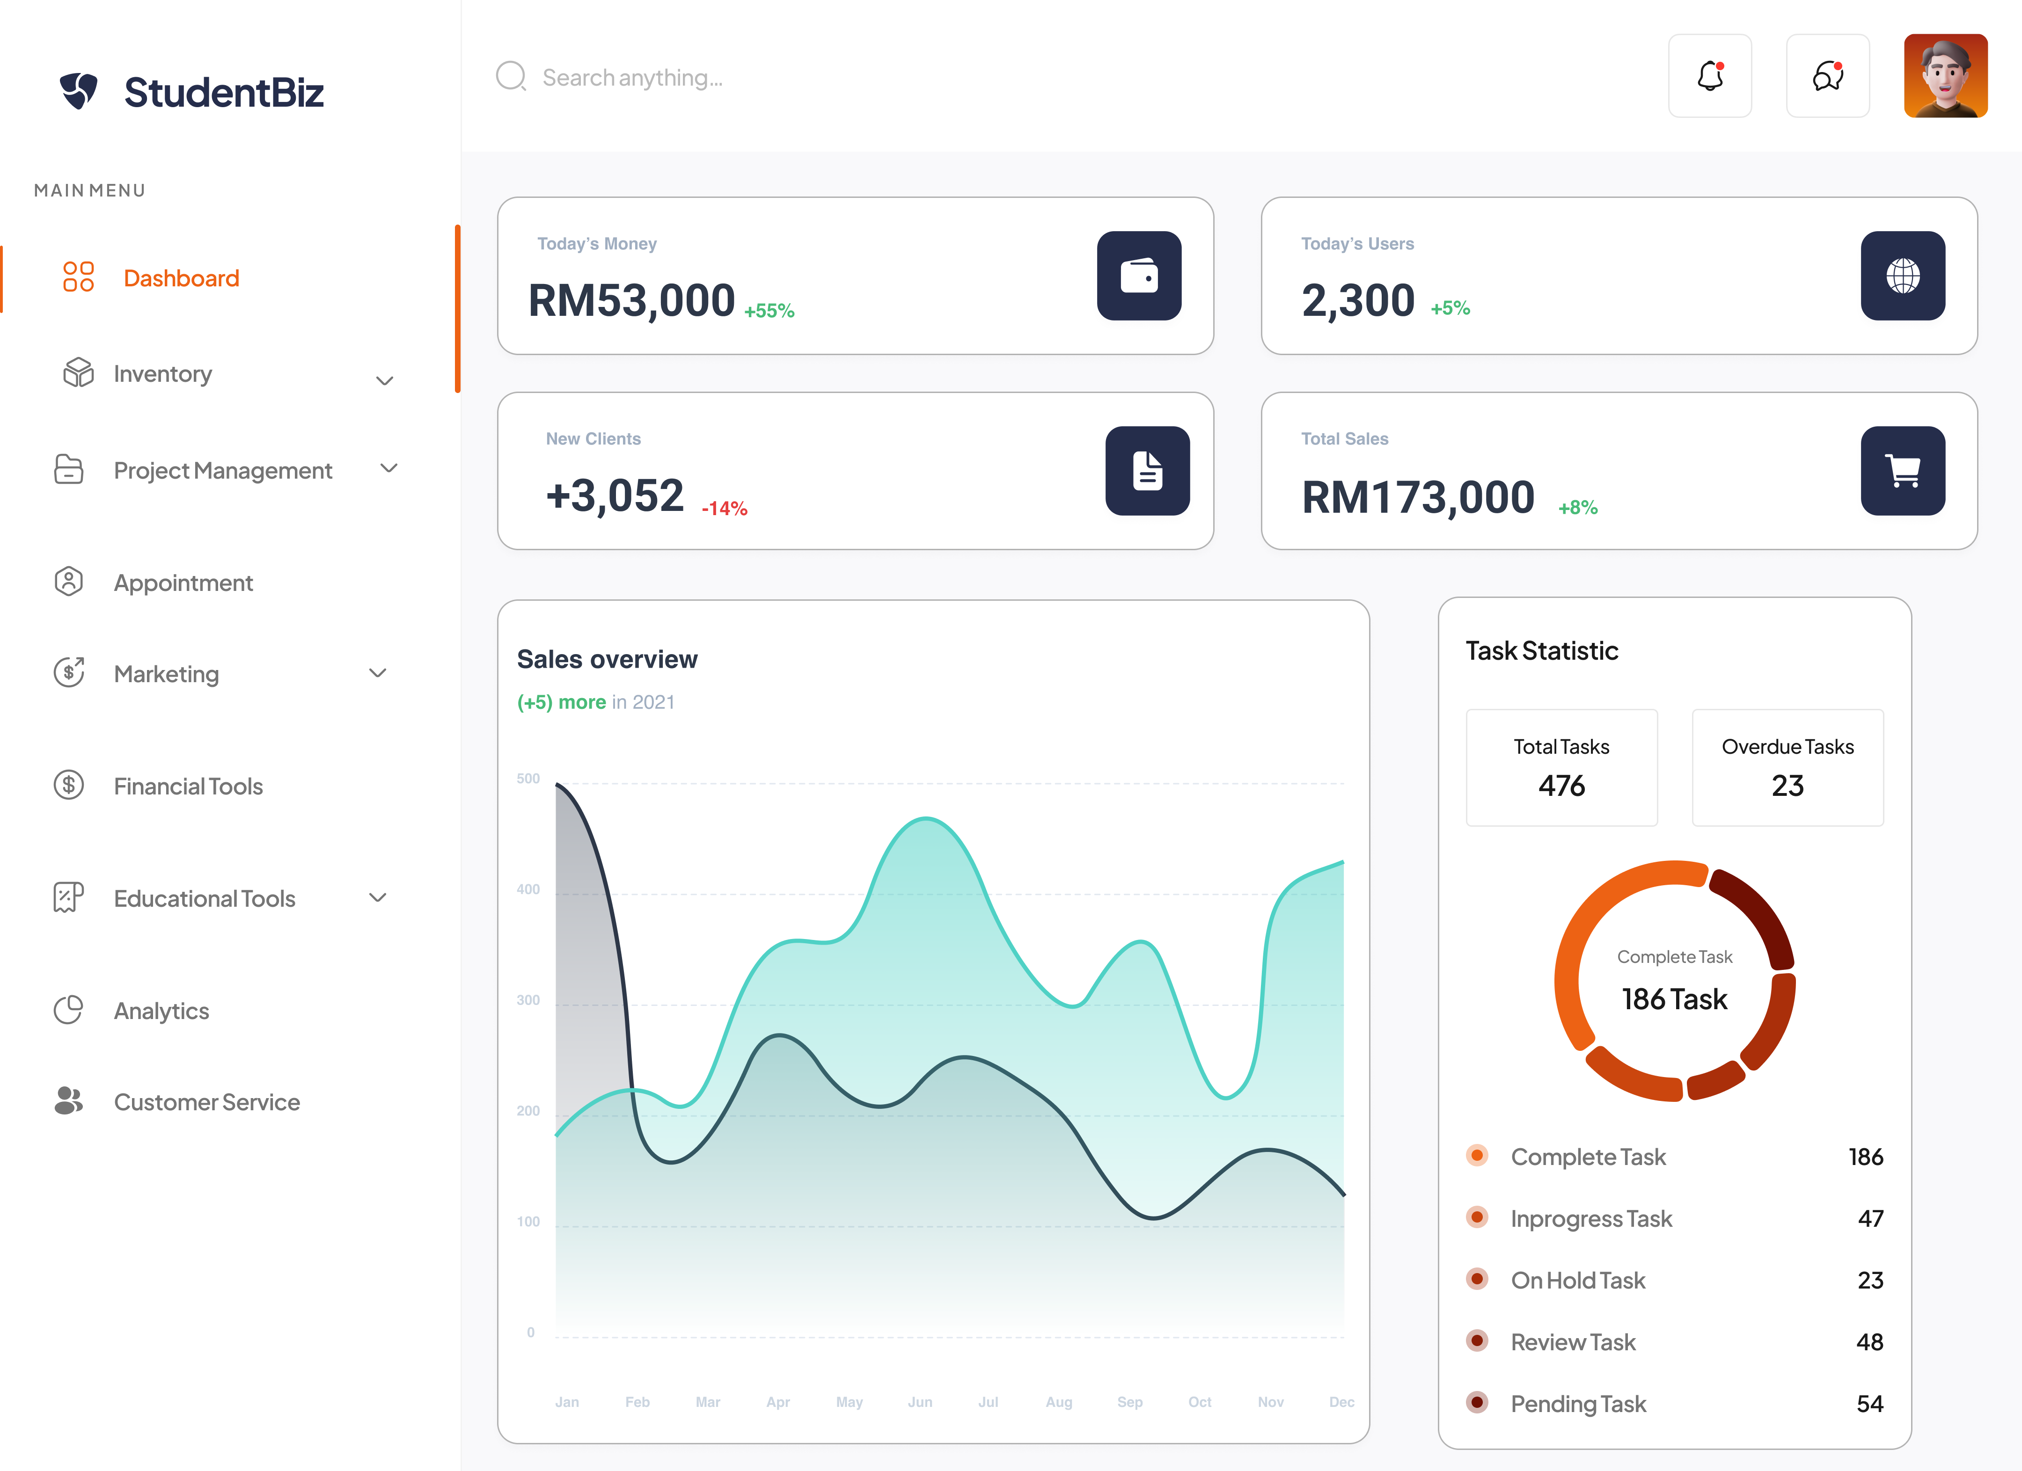

Figure 1.3 displays the home page of StudentBiz, which serves as the dashboard. The dashboard enables users to view the business's sales overview, task statistics, and other relevant details. Additionally, users can access various functionalities through the main menu, encompassing inventory, project management, appointment scheduling, marketing, financial tools, educational resources, analytics, and customer service.

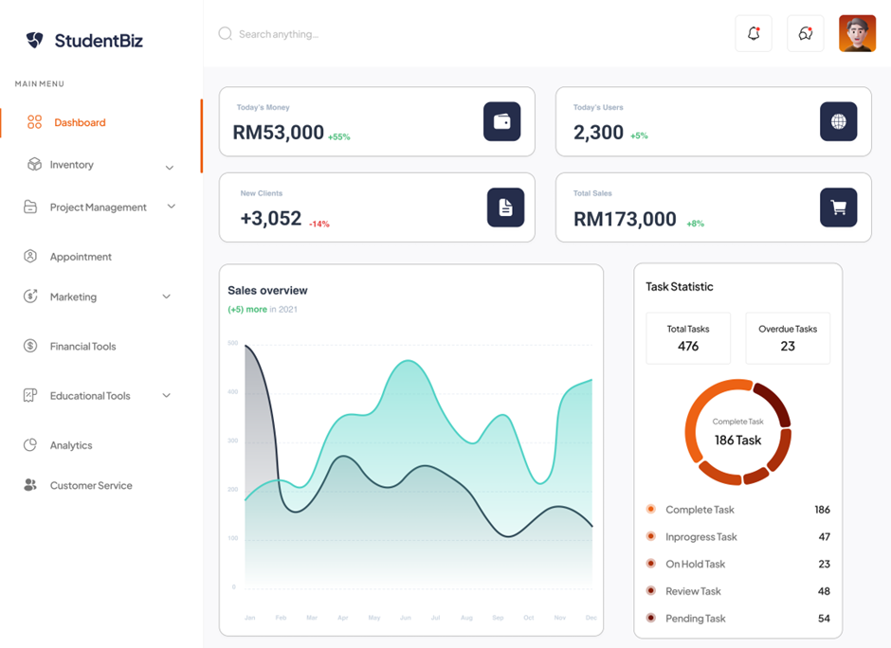

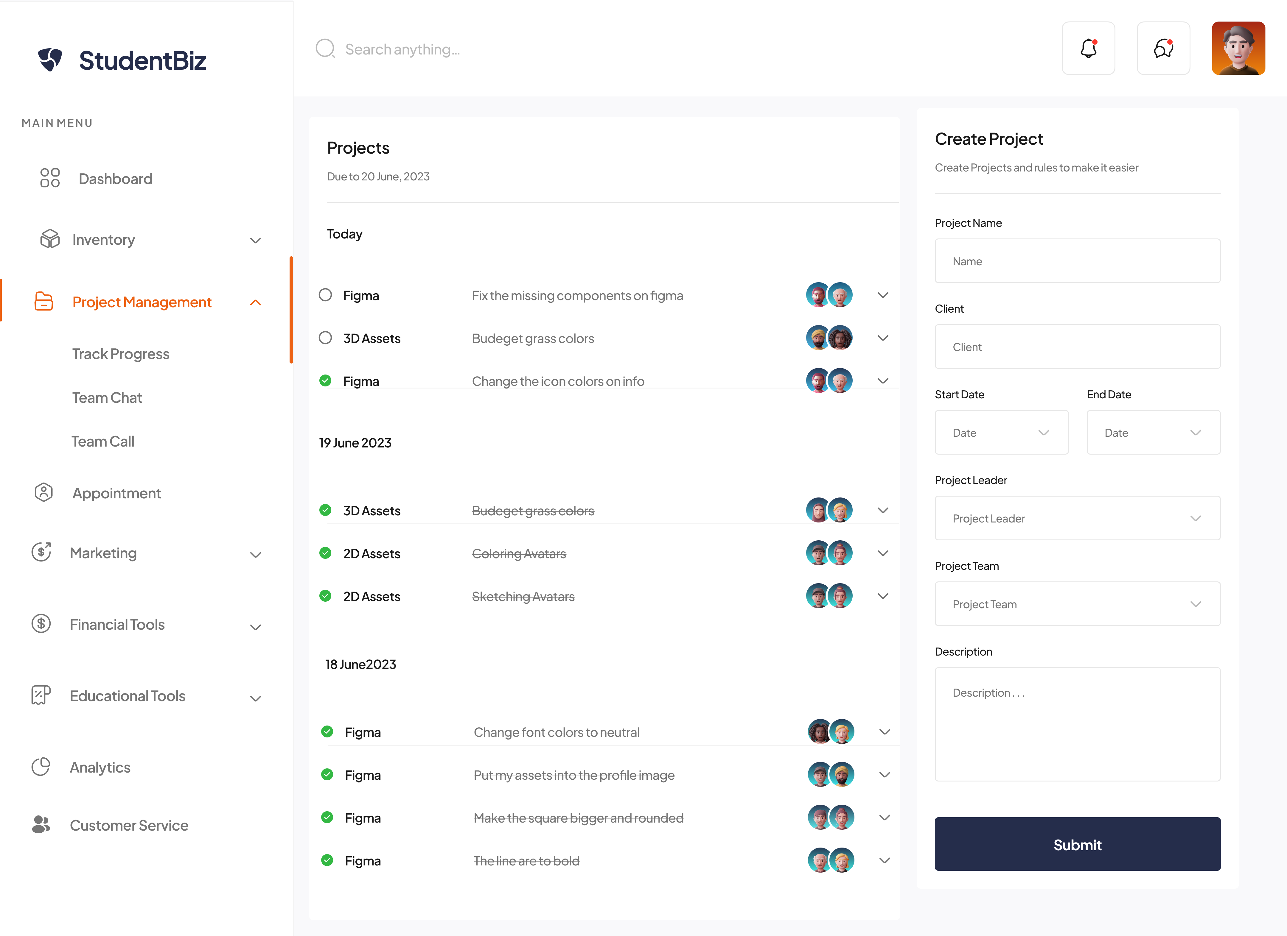

Assign Task

Set Deadlines

Create Task

Figure 1.4 illustrates the Project Management Page, which allows users to view both ongoing and completed projects. Users are able to create new project tasks, assign tasks to specific individuals, set deadlines, and more.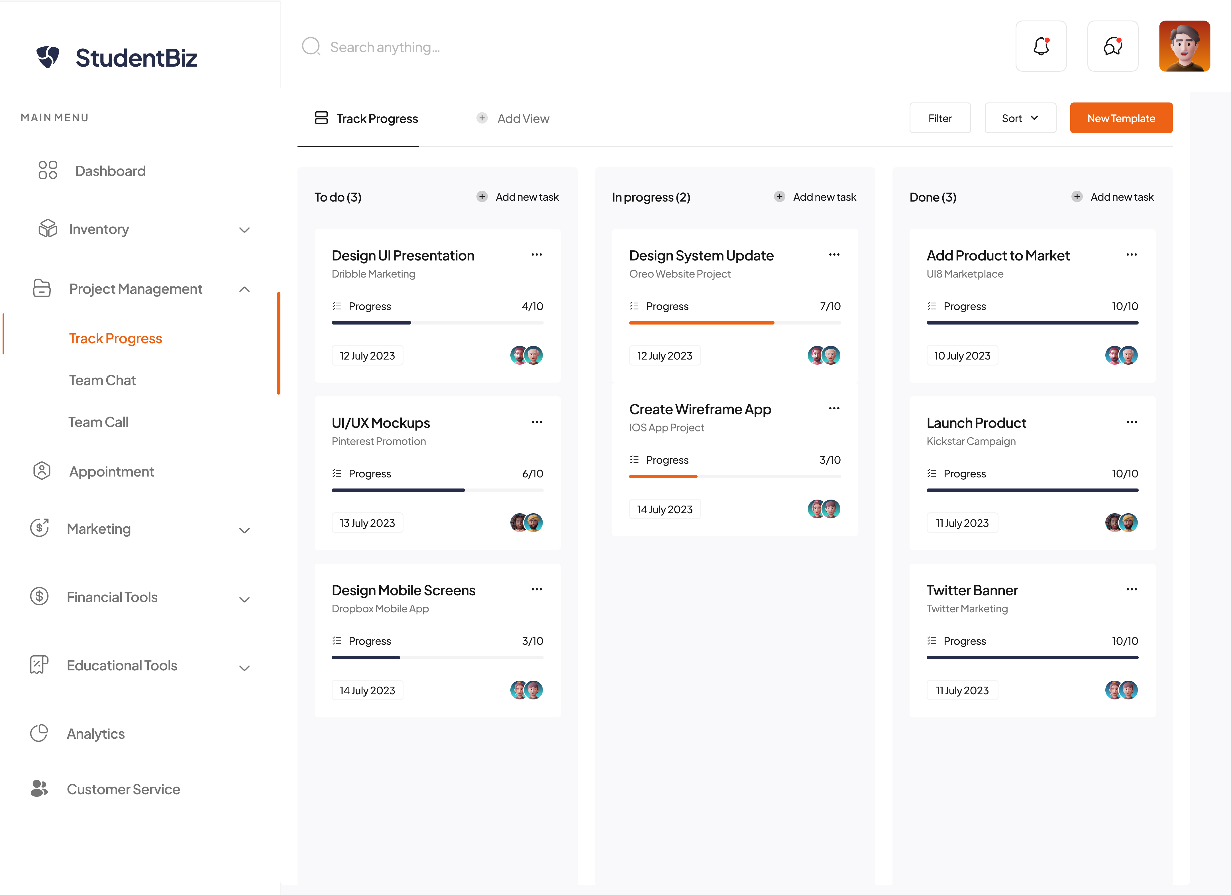

Figure 1.5 shows the Track Progress function under Project Management. It enables users to monitor the progress of tasks completed by teams or individuals. Users can also view tasks that are yet to be done, tasks that are currently in progress, and tasks that have been completed.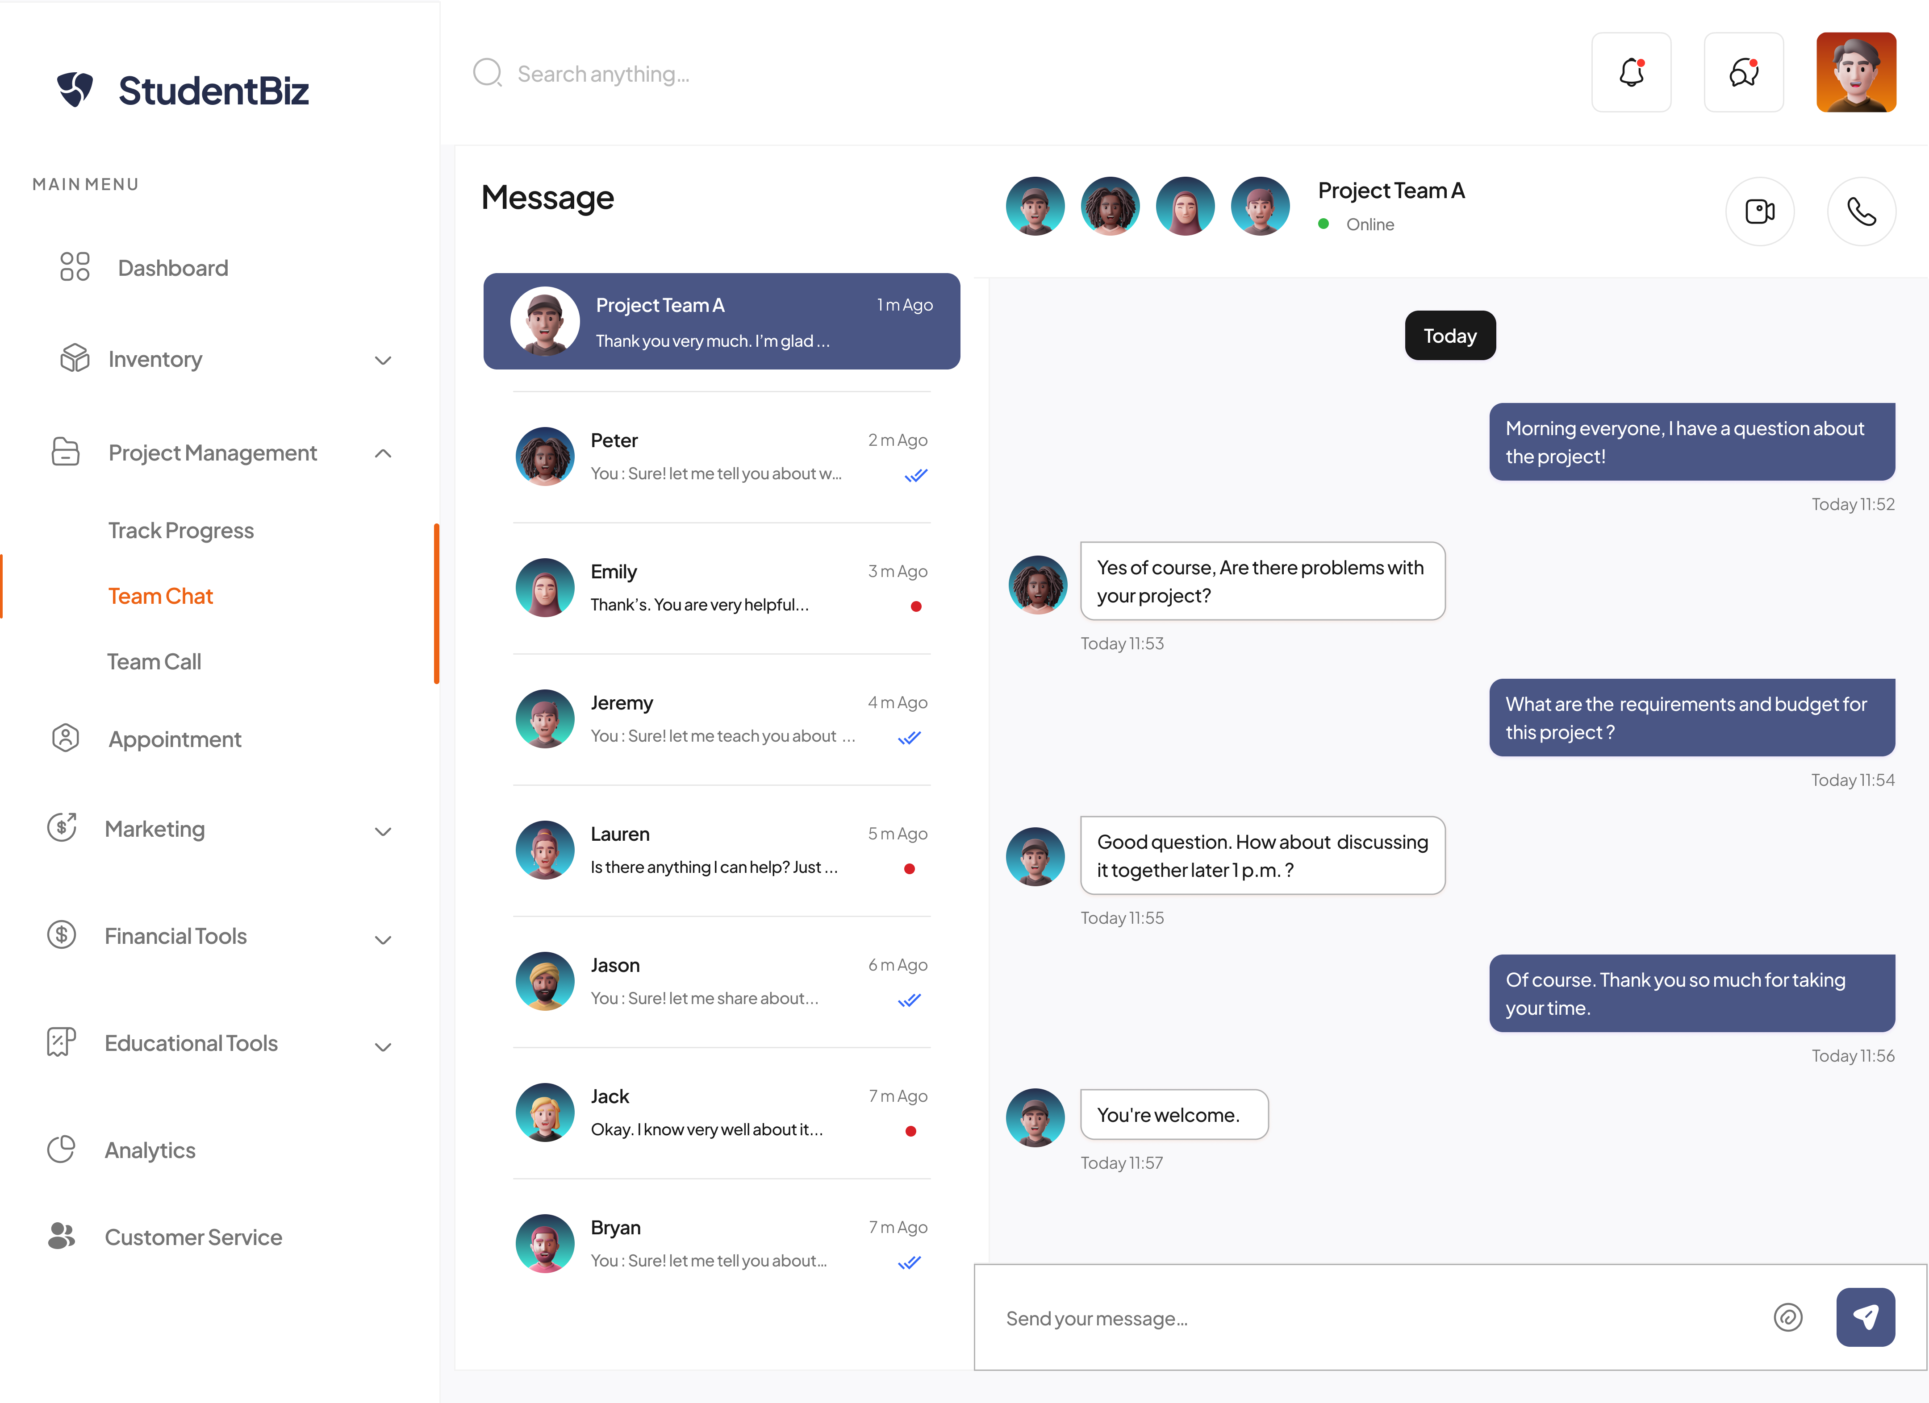

Figure 1.6 showcases the Team Chat function within Project Management. This feature allows users to communicate and engage in discussions about the project they are working on through the system.

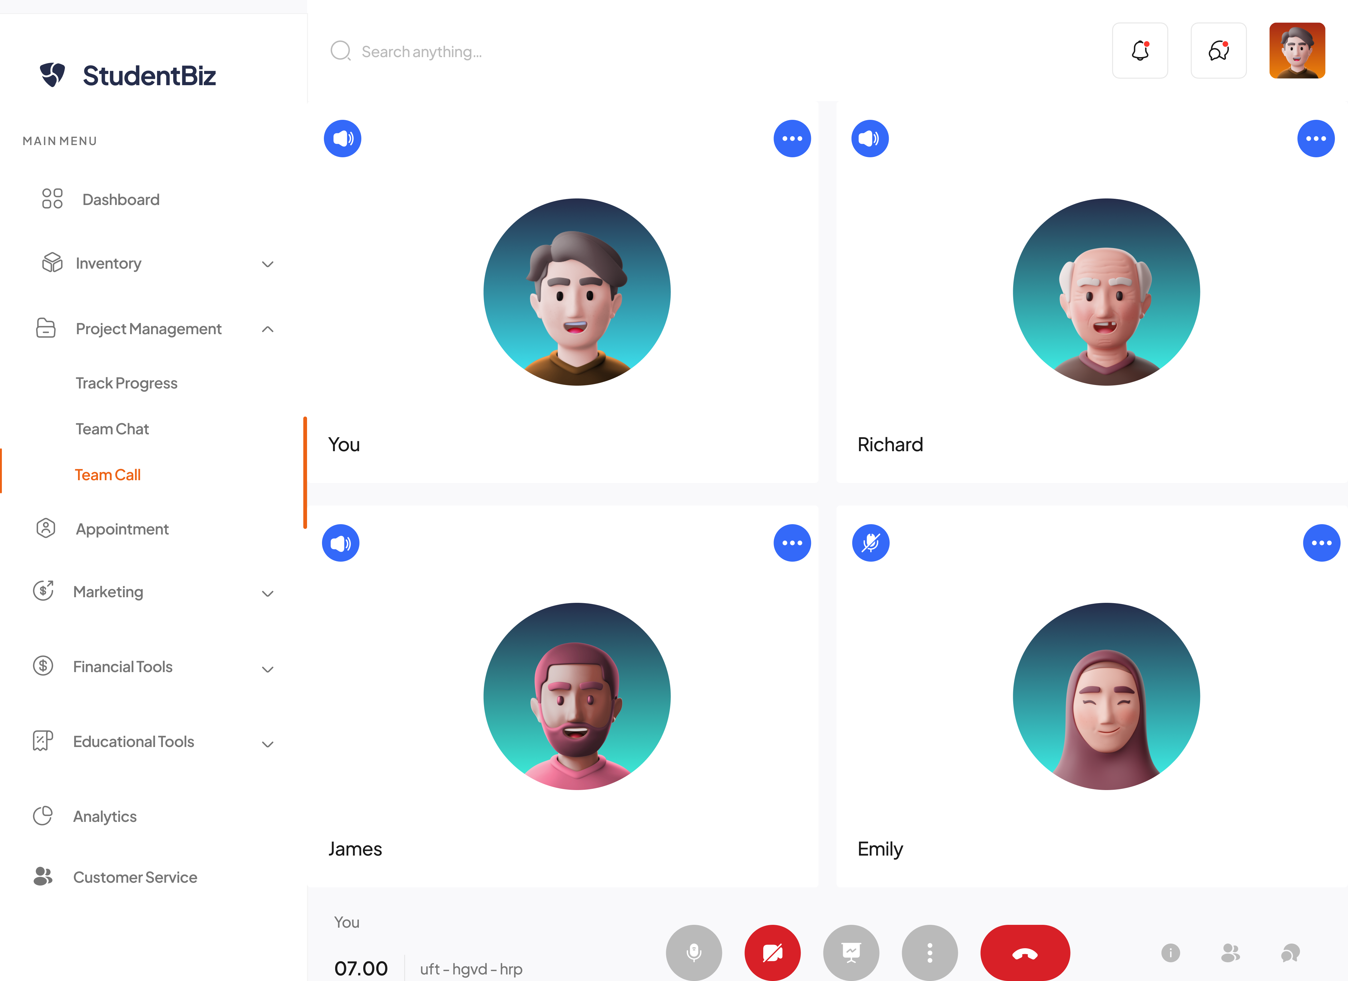

Figure 1.7 presents the Team Call function within Project Management. This feature allows users to make voice calls through the system to have discussions with their teammates, facilitating clearer and more detailed information exchange.

**1.2 Inventory User Interface**

The Inventory function enables users to keep track of their product inventory effectively It offers various features, including the ability to add, update, and delete inventory items, monitor the quantity of inventory, access suppliers' information and interactions, and generate reports on product availability. This function helps users ensure they have sufficient stock on hand, make informed purchasing decisions, and avoid stockouts or overstocking.

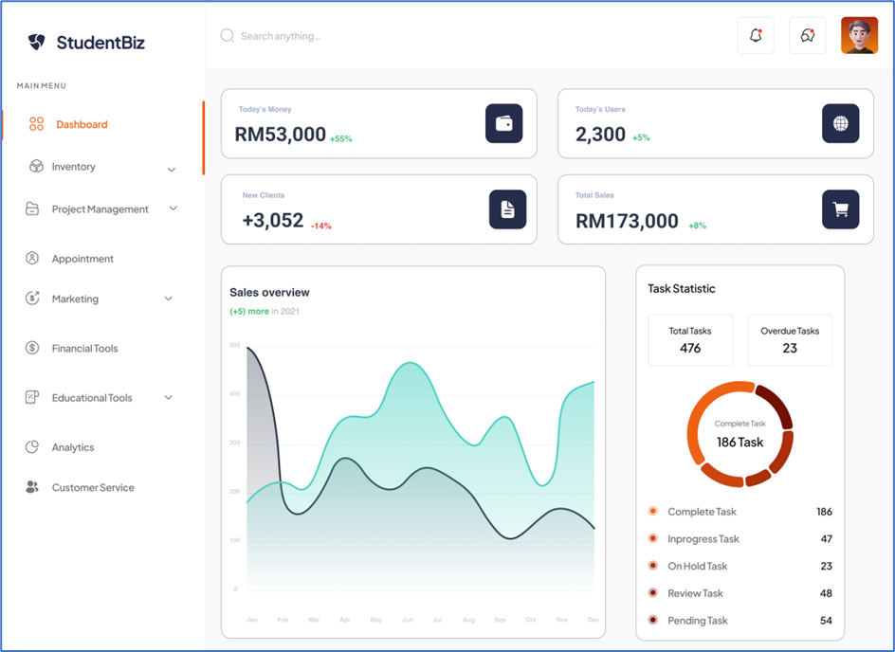

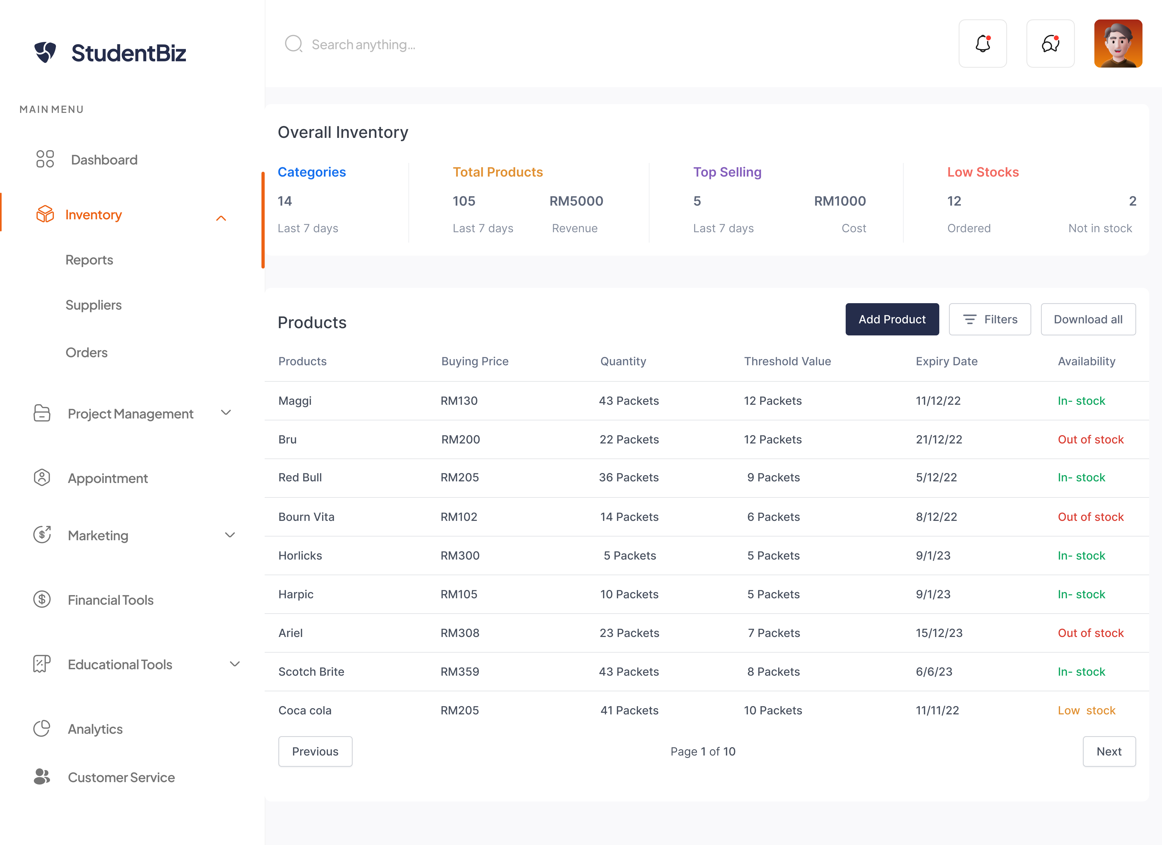

Figure 1.8 illustrates the Inventory Page, providing users with an overview of the overall inventory details and the list of products present in the system.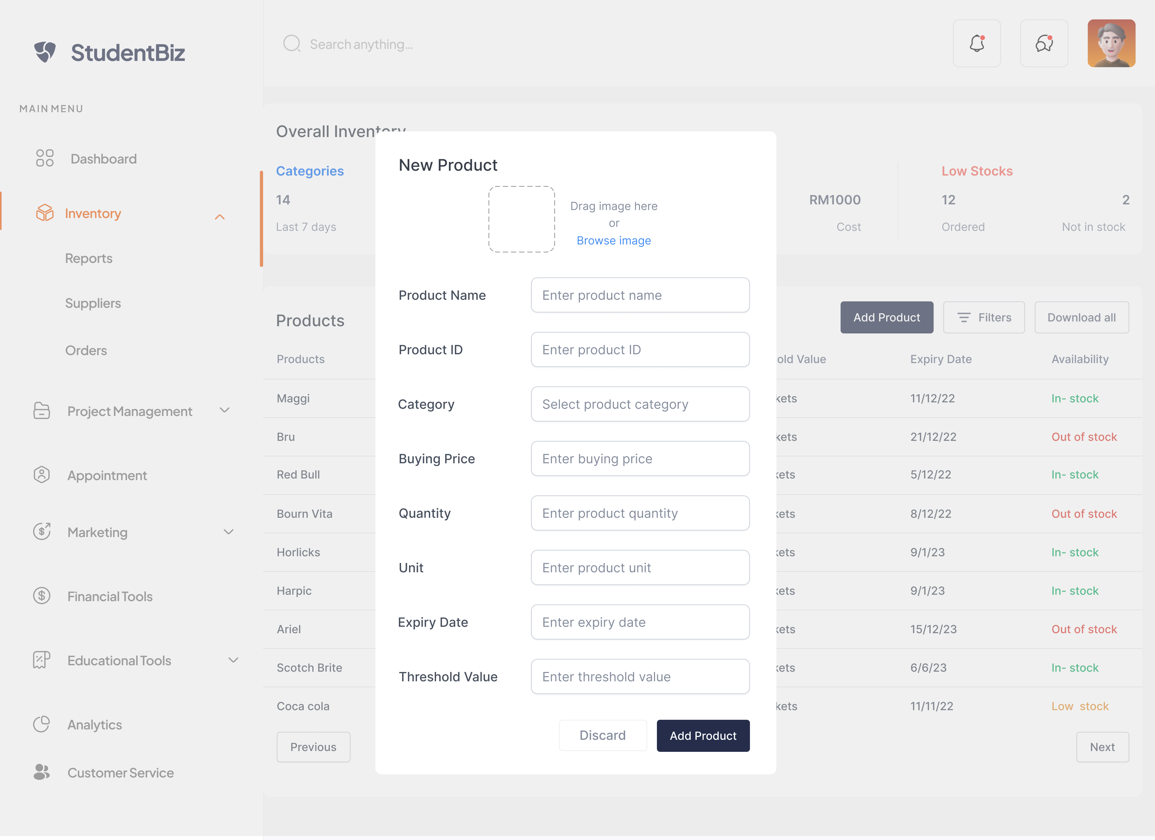

Figure 1.9 shows the Add Product function, which enables users to input and add new product details such as the product name, ID, category, price, quantity, expiry date, and other relevant information.

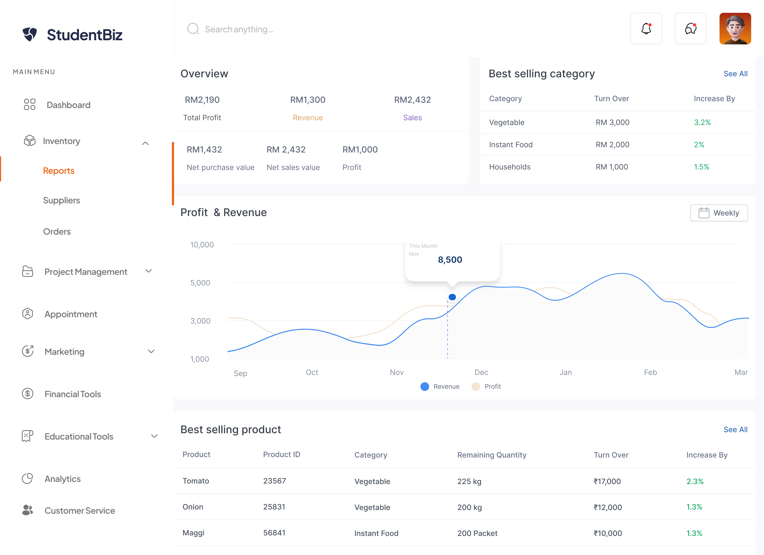

Figure 1.10 showcases the Report page within the Inventory section. This page enables users to access and view information such as the best-selling categories and products, profit and revenue figures, and generates relevant reports based on the provided data.

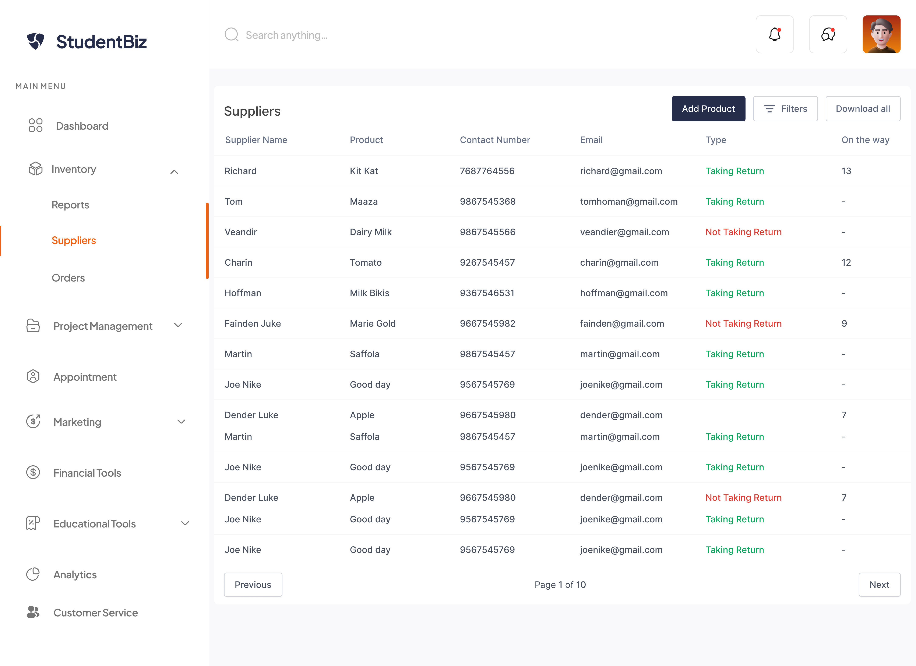

Figure 1.11 presents the Supplier List, where users can access and view comprehensive information about all the suppliers and relevant details regarding the products they are returning.

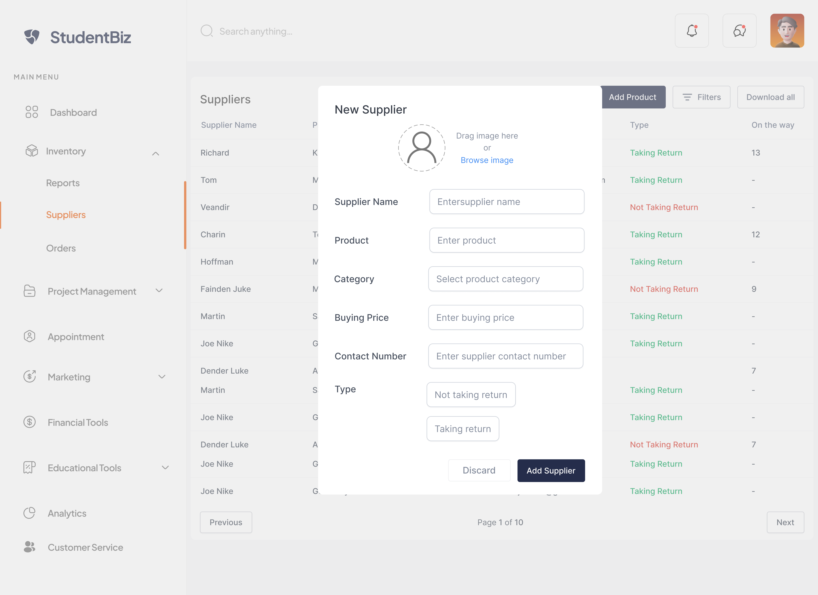

Figure 1.12 shows the Add Supplier function, which allows users to input and add new supplier information such as the supplier's name, the products they supply, category, price, contact number, and other relevant details.

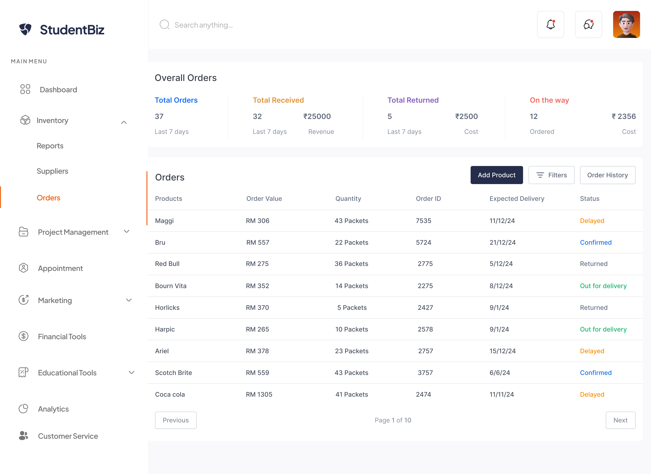

Figure 1.13 showcases the Order Page, where users can place orders for products that are running low in stock through the system. Users can view various details including the ordered products, order value, quantity, ID, expected delivery time, and status of the order.

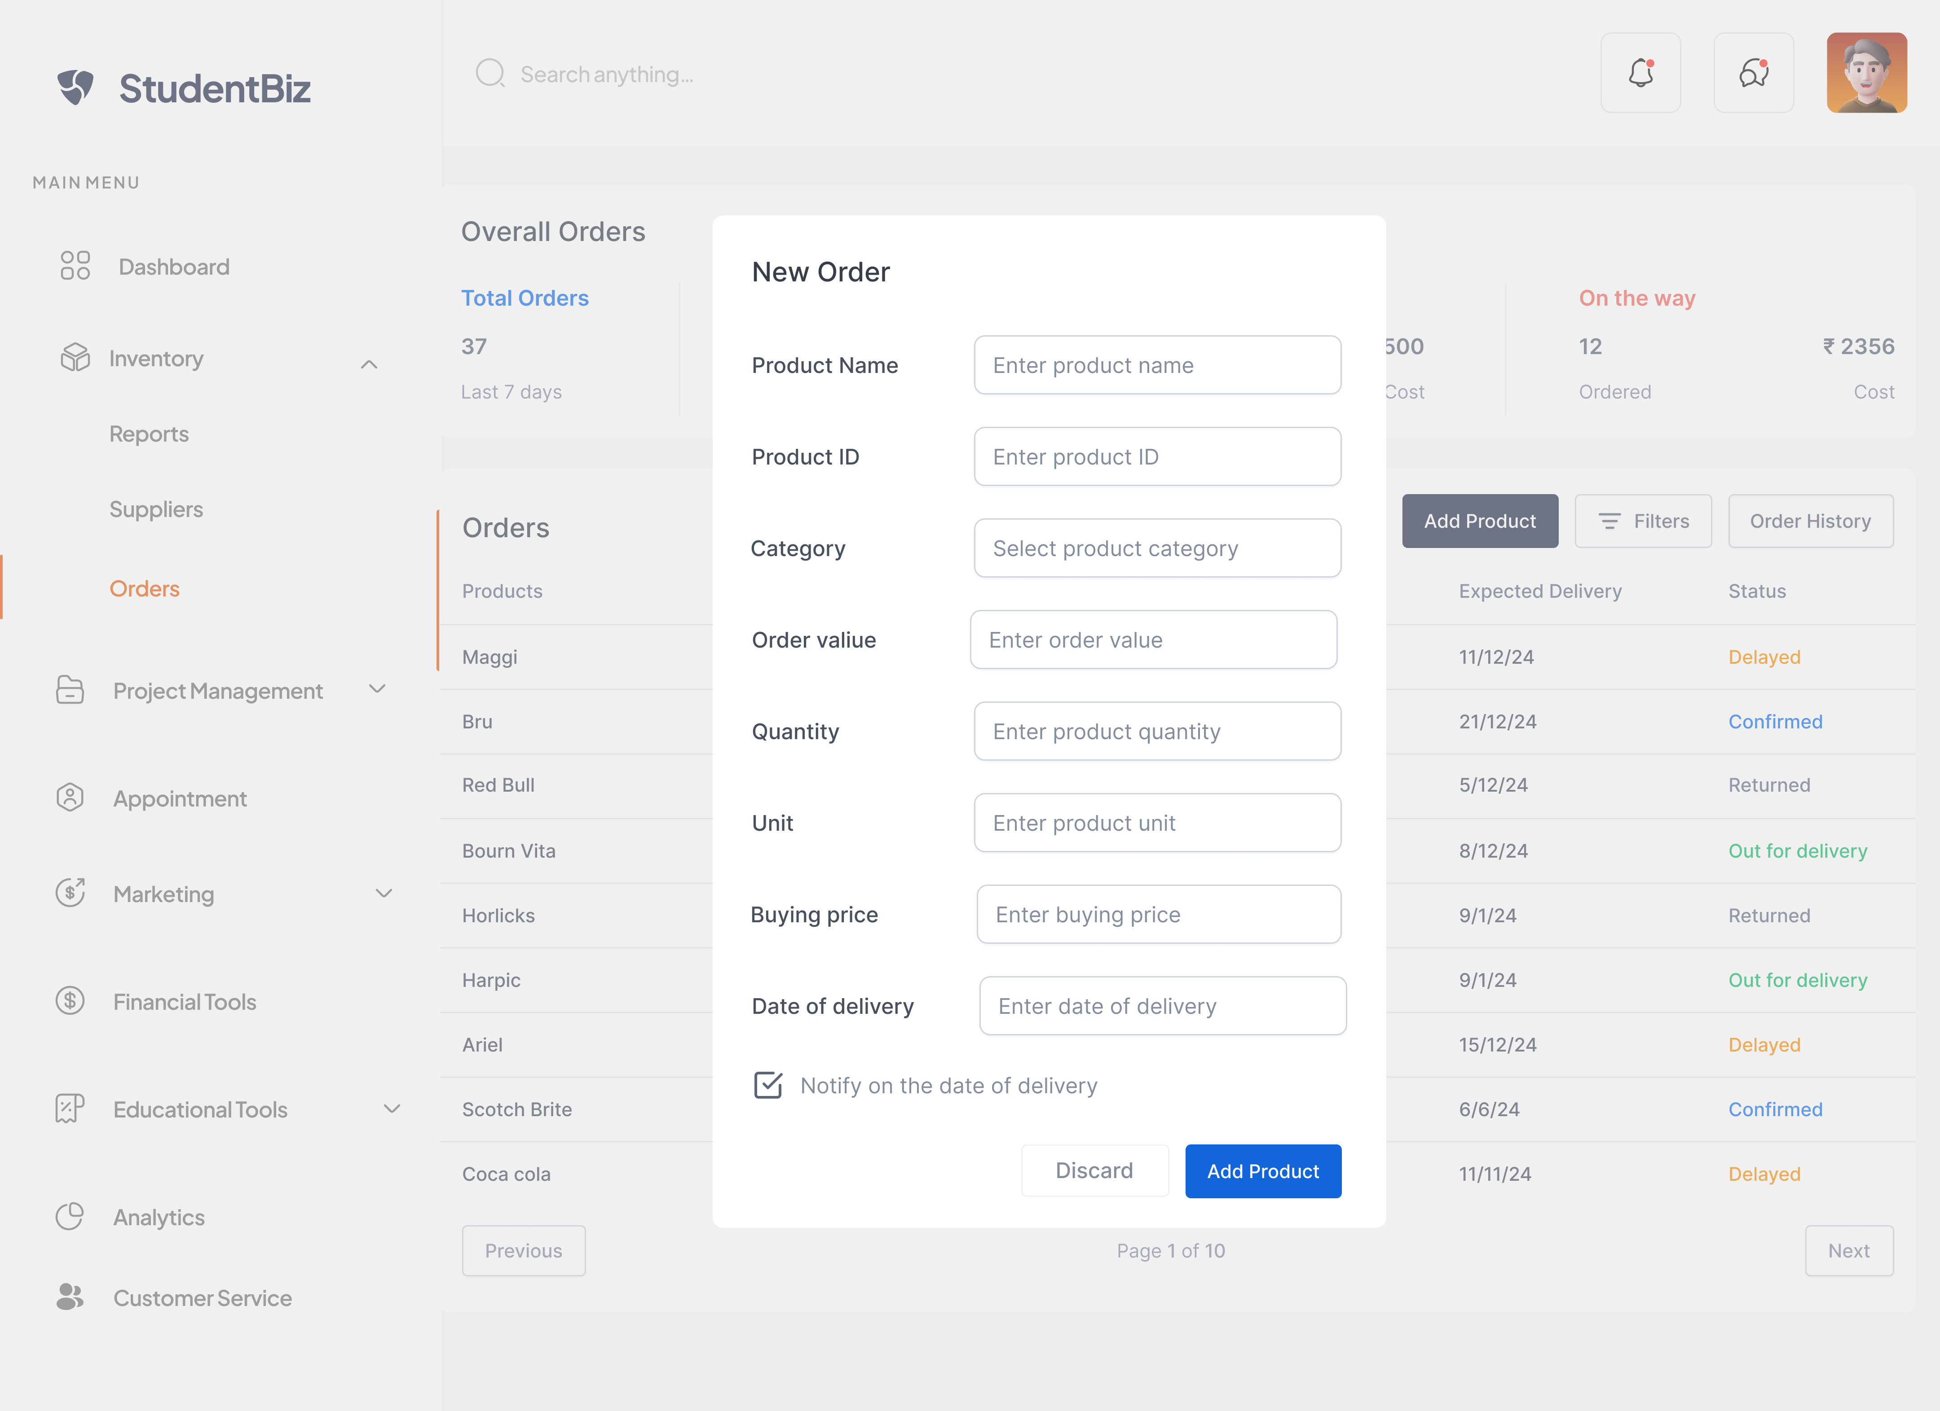

Figure 1.14 depicts the Add New Order function, which enables users to input the necessary details for a product that needs to be ordered. Users can enter information such as the product name, ID, category, order value, quantity, price, and other relevant details when placing a new order.

**2.0 Usability Testing**

Usability testing plays a crucial role in the development and improvement of software systems, ensuring that they meet user expectations, are easy to use, and provide a satisfactory user experience. The testing focused on assessing the usability of the project management and inventory features.

The purpose of usability testing is to evaluate how well a system or specific features meet the needs of its intended users. It involves observing users as they interact with the system, collecting feedback, and analyzing their experiences to identify areas of improvement. By conducting usability testing, we gain valuable insights into the strengths and weaknesses of the system, allowing us to make informed design decisions and enhancements.

**2.1 Usability Testing Questions**

**Usability Testing Questions for Project Management:**

1. How easy was it to create a new project in the system?

* Testing for the ease of creating projects and assessing the clarity of the process.

1. Were you able to assign tasks to team members easily?

* Testing for the ease of assigning tasks and evaluating the efficiency of the task management feature.

1. Did you find it intuitive to set deadlines for project tasks?

* Testing for the clarity and ease of setting task deadlines and assessing the user's understanding of the feature.

1. How clear was the project progress tracking feature?

* Testing for the user's understanding of the project progress tracking functionality and evaluating its effectiveness in providing clear project insights.

1. Were you able to collaborate and communicate effectively with team members within the project management chat and call feature?

* Testing for the ease of collaboration and assessing the efficiency of communication and coordination features.

**Usability Testing Questions for Inventory Management:**

1. How easy was it to add new inventory items to the system?

* Testing for the ease of adding new inventory items and assessing the clarity of the process.

1. Did you find the process of tracking inventory reports or summaries straightforward?

* Testing the ease of tracking inventory reports or summaries and assessing the user's understanding of the process.

1. How easy was it to access the supplier information for a specific item in the inventory?

* Testing the ease of accessing supplier details and assessing the efficiency of the process.

1. Did you find it straightforward to add new suppliers to the system?

* Testing the intuitiveness and ease of adding new suppliers to the system and evaluating the user's understanding of the process.

1. How easily were you able to view the list of orders from suppliers in the system?

* Testing the ease of accessing and navigating the order list to view the orders from suppliers.

1. How intuitive was the process of adding a new order from a supplier to the system?

* Testing the user's understanding of the steps involved in adding a new order and evaluating the ease of completing the process.

1. How satisfied were you with the overall experience of viewing and adding orders from suppliers in the inventory system?

* Testing the user's overall satisfaction with the functionality and usability of the order management features.

The usability testing questions aim to assess the user's experience with the project management and inventory management functions of the system. They focus on evaluating the ease of use, clarity of processes, efficiency of features, and overall user satisfaction. The feedback gathered from these questions will help identify any usability issues and areas of improvement for enhancing the user interface and functionality.